Distribution of groceries to the most suffering families of Kannagi Nagar,
Aided by La Gioa Di Vivere
18.10.2020

Kannagi Nagar Resettlement colony is one of the Asia’s largest slum resettlement colonies consists of 72 slums.
This year Marialaya , NGO running by Salesian Sisters, Chennai is working for the promotion of 9 slum settlers in Kannagi nagar
Every settlement have 3 staff members, so we have 27 staff members are working there.
Identification of the families:
Our 27 staff members and 3 Corporation appointed Health workers who visit all the houses every day to find out the corona victims.
They identify the families and report to Marialaya.
1.Covid 19 affected families
2. jobless / income less families
3. families with elders and children
4. people who don’t have ration Card and who are not able to receive free ration from the Government.

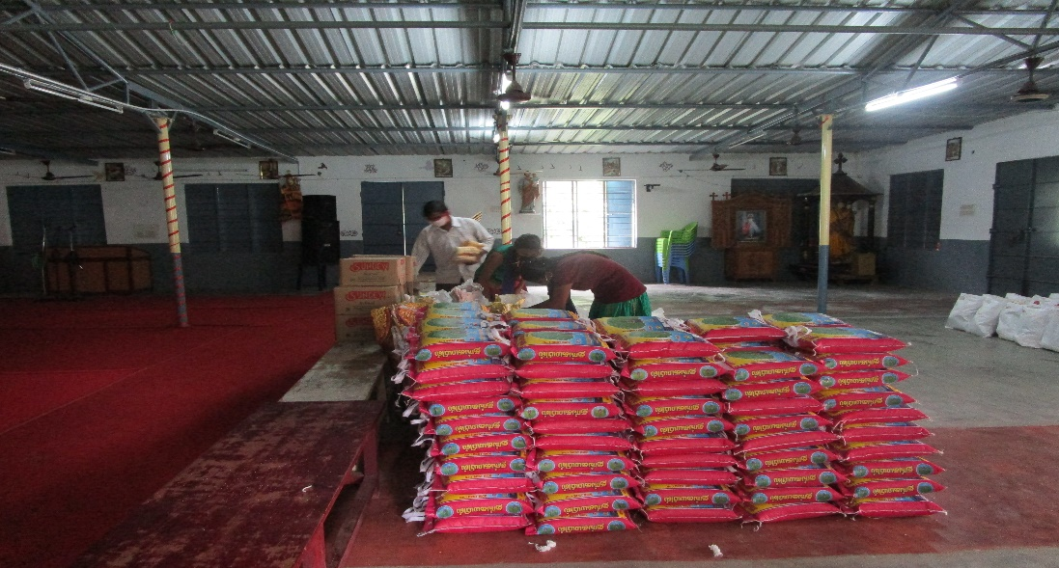

On 18th October 2020 Marialaya Kannagi Nagar distributed groceries to 200 families. The groceries include, Rice, dhal, Oil. Atta and Sugar.
The Covid 19 situation has shattered the lives of the families of Kannagi Nagar who are mostly day wage earners employed mostly in the informal sector
People struggled a lot to survive and they are in desperate situation due to long period of lock down and the loss of their daily work but our timely help gave them great support. They expressed their sense of gratitude and with tears in their eyes thanked the donor. It was an apt time that we distributed the provision to Kannagi Nagar people since the government support was not sufficient for them.
We have seen that many people are supporting the physically challenged people, workers from other states who are residing here without work and food and the transgenders etc. We have studied the situation and we distributed food supply to the people who are in great need and haven’t receive any help from any NGO or any Government
Our sincere and heartfelt thanks to La Gioa Di Vivere for your support and generous help. It is a good initiative and great help to the poor people during this pandemic condition of COVID-19 where the people were in lock down and they were not able to go out for their regular works. They are all daily wages who are unable to support the family but your help will sustain them for at least for 10 days. While distributing things, we witnessed that the joy on their faces and they expressed their sincere gratitude to towards the donors for fulfilling their needs at this very difficult juncture.
Distribution of Mask and Sanitizer:
We distributed Mask and sanitizers for children and advised them to use it regularly and sanitize their hands properly. Children were very happy and they promised us that they will always wear the mask and keep their hands clean.
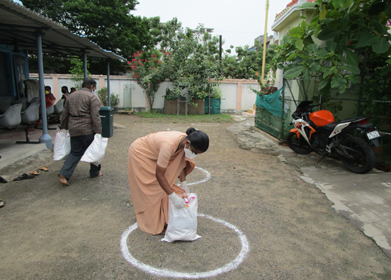
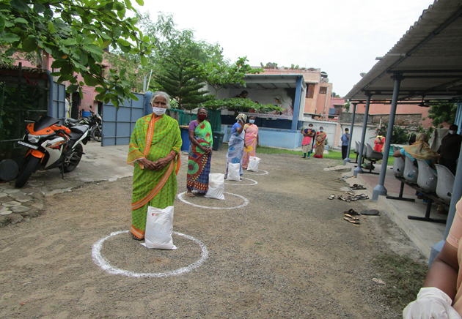
The staff and Management also take this opportunity to thank La Gioa Di Vivere for this great help and we look forward your future aid for these most vulnerable people and for the youth of Kannagi Nagar.

Thank you

